**Name:** sohaila said Mohamed tantawy

**B.N:** 401

**Date: 3/6/2020**

**Topic:** Programming Languages

**Github link:** <https://github.com/sohailasaid/Programming-Languages->

**Github page:** <https://sohailasaid.github.io/Programming-Languages-/>

**Application brief:**

A programming language is a [formal language](https://en.wikipedia.org/wiki/Formal_language) comprising a [set of instructions](https://en.wikipedia.org/wiki/Instruction_set_architecture) that produce various kinds of [output](https://en.wikipedia.org/wiki/Input/output). Programming languages are used in [computer programming](https://en.wikipedia.org/wiki/Computer_programming) to implement [algorithms](https://en.wikipedia.org/wiki/Algorithm).

Most programming languages consist of [instructions](https://en.wikipedia.org/wiki/Machine_instruction) for [computers](https://en.wikipedia.org/wiki/Computer). There are programmable machines that use a set of [specific instructions](https://en.wikipedia.org/wiki/Domain-specific_language), rather than [general programming languages](https://en.wikipedia.org/wiki/General-purpose_language). Early ones preceded the [invention of the digital computer](https://en.wikipedia.org/wiki/History_of_computing_hardware), the first probably being the automatic flute player described in the 9th century by the [brothers Musa](https://en.wikipedia.org/wiki/Ban%C5%AB_M%C5%ABs%C4%81) in [Baghdad](https://en.wikipedia.org/wiki/Baghdad), during the [Islamic Golden Age](https://en.wikipedia.org/wiki/Islamic_Golden_Age).[[1]](https://en.wikipedia.org/wiki/Programming_language#cite_note-1) Since the early 1800s, programs have been used to direct the behavior of machines such as [Jacquard looms](https://en.wikipedia.org/wiki/Jacquard_loom), [music boxes](https://en.wikipedia.org/wiki/Music_box) and [player pianos](https://en.wikipedia.org/wiki/Player_piano).[[2]](https://en.wikipedia.org/wiki/Programming_language#cite_note-2) The programs for these machines (such as a player piano's scrolls) did not produce different behavior in response to different inputs or conditions.

**Some applications:** Most popular languages and their uses:

1. Java
2. Python
3. JavaScript
4. C#
5. C++
6. PHP
7. C
8. Ruby
9. R
10. Perl

**Screenshots:**

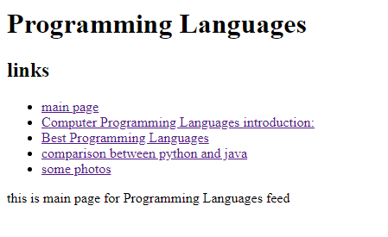

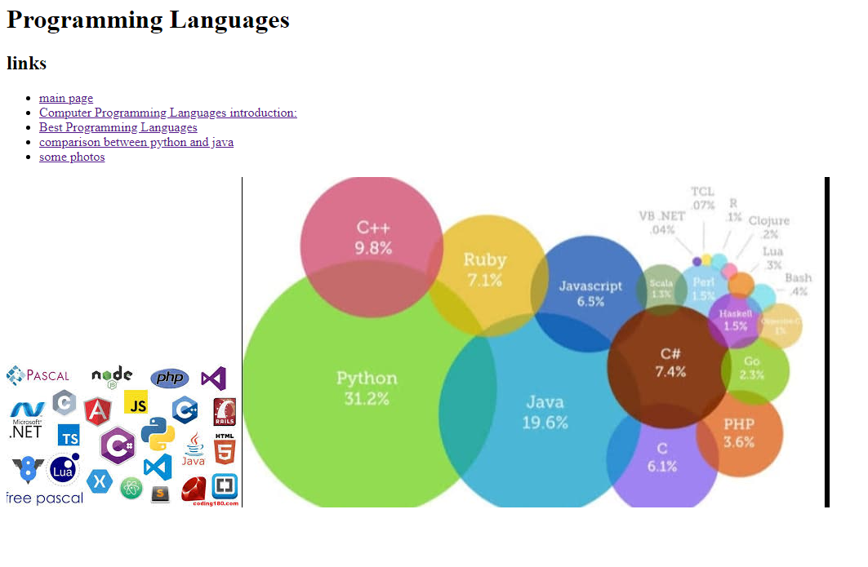

**Source code:**

